Ideation Phase
Brainstorm & Idea Prioritization Template
Date | 01-10-2026 | Team ID | SWTID-2026-5415
Project Name | Import Data Using Transform Maps (Spreadsheet) | Maximum Marks | 4 Marks
Brainstorming focuses on the project problem: moving spreadsheet data into ServiceNow through Transform Maps with reliable field mapping and controlled access.

Step-1: Team Gathering, Collaboration and Select the Problem Statement
Selected problem: How can a team import spreadsheet data into ServiceNow accurately, transform it into the target table, relate records to Employee, and verify access?

Step-2: Brainstorm, Idea Listing and Grouping
Idea | Group | Project Relevance
Prepare spreadsheet with source fields | Data preparation | High
Create Import Set / Load Data | Import | High
Create Transform Map | Transformation | High
Use Employee reference | Relationship | High
Use dot-walking to Department | Related data | High
Configure role and Read/Write ACLs | Security | High
Test using Impersonate | Validation | High
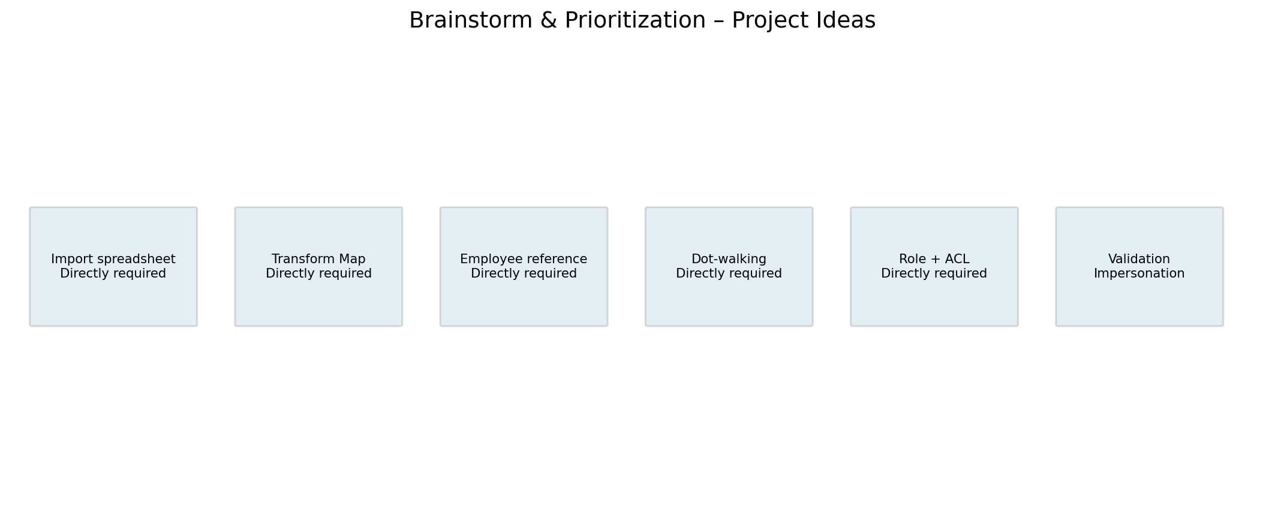

Step-3: Idea Prioritization
Priority | Selected Idea | Reason
1 | Transform Map | Core mechanism for mapping spreadsheet fields to the target ServiceNow table.
2 | Import Set | Required entry point for spreadsheet data.
3 | Employee reference + dot-walking | Provides related employee and Department information.
4 | Role + ACL | Protects records according to access requirements.
5 | Impersonation | Confirms the configured access behavior.

